UCLA Center for Language, Interaction, and Culture
— Registration Now Open —



GailBot

Weekend Hackathon

Friday − Sunday
April 12-14

REGISTER HERE

Space is limited,
register now to secure your spot.
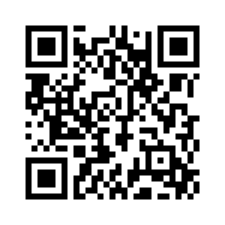

GailBot is a 'first pass' automated transcription system designed to support conversation analytic research. Human interaction research relies on detailed transcriptions of language use (a system developed by conversation analyst Gail Jefferson, after whom GailBot is named) that are very slow and expensive to produce. GailBot makes it possible to produce first-pass detailed transcripts of dialogue at scale.
The GailBot development team will be visiting UCLA April 12th - 14th to run a 'hackathon' (2-4 hours per day) with the goal of adapting GailBot to fit a range of CA research workflows. Participants will learn about its capabilities, use cases, and limitations, as well as how to install, configure, and use the program. Note: Currently GailBot is only available on Mac, but the development team is working on a Linux package.
Program details coming soon, but if you have questions about coming for part of the hackathon or whether your data is appropriate, register and put your question in the form. We’ll respond.

GailBot Team:
Saul Albert — Senior Lecturer in Social Sciences, University of Loughborough
Muhammad Umair — Department of Computer Science, Tufts
Vivian Li — Department of Computer Science, Tufts
Julia Mertens — Senior Scientist at Boston Fusion Corp.
J.P. De Ruiter — Department of Computer Science and Department of Psychology, Tufts
Learn more about GailBot here: https://sites.tufts.edu/hilab/gailbot/

